**Project Title:** Walmart Labs Project

**Author:** Anish Kumar

**Overview**

This document provides details about the automated scenarios implemented against

Walmart product page: https://www.walmart.ca/en/ip/google-home-speaker/6000197114649

**Prerequisites**

Java Development Environment Setup

**Files:**

Test file 'ItemPage.java' is present under \src\com\item\page

Extent Report files are present under \src\com\item\report

Since it is a java project, the required jar files should be added in Java Build Path🡪Libraries, and the files are present under $workspace\'jar_files' folder.

**Execute the test:**

1. Clone the project to local repository.

2. Add the required jar files from $workspace\'jar_files' to Java Build Path 🡪Libraries

3. Run as TestNG suite by right clicking on testing.xml file. Three test scenarios will be executed.

**Reporting**

After execution of test cases, two types of reports are generated:

1. Under test-output folder, default TestNG report is generated. It provides details about test executed, pass, fail & overall time execution.

2. Under TestReport folder, Test-Automation-Report.html is generated using ExtentReports API . It provides all test information in detailed test steps and in graphical representation.

Extent Reports sample:

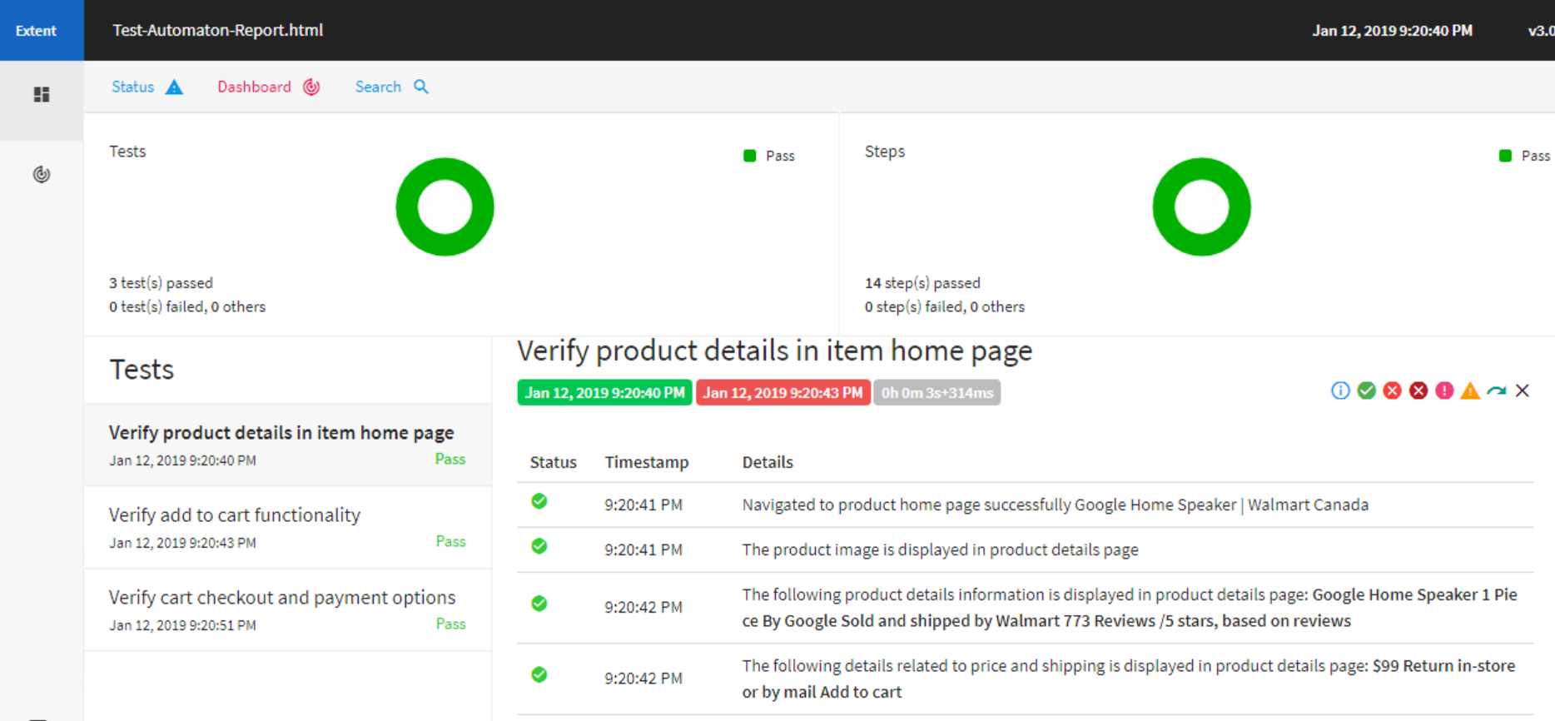

TestNG report sample:

